Sprintax Suggested Content for School Tax Page:

Who must file tax forms for 2019 tax season?
If you were physically in the U.S. in J status anytime between January 1 - December 31, 2019 you're obligated to send one form, Form 8843, to the U.S. tax agency IRS (Internal Revenue Service), even if you had no income. For the 2019 tax season, if you earn any US income, you will need to file a federal tax return with the IRS by law. Failure to file a Federal tax return will breach IRS regulations and may inhibit you from returning to the US on any future visas. Depending on your individual circumstances, you may also need to file a state tax return(s).
Tax Filing Deadline:
April 15th, 2020 is the last day for residents and non-residents who earned U.S. income to file Federal tax returns for 2019.
Resident or Non-Resident for Federal Tax Purposes:
Generally, most J1 Summer Work and Travel, J1 Interns/Trainees, J1 Camp Counsellors and J1 Au Pairs are considered non-residents for tax purposes. The above J visas are automatically considered non-residents for 2 out of the last 6 calendar years in the US. If you’ve been in the US for longer than 2 years for the last 6 years period, the Substantial Presence Test will determine your tax residency.
How to File:
We have teamed up with Sprintax to provide you with easy-to-use tax preparation software designed for non-residents in the U.S.
After you login to Sprintax, it will ask you a series of questions about the time you have spent in the United States and in which immigration status, looking back over a period of years. Sprintax will then determine your tax status. If it determines that you are a "nonresident alien" (NRA) for federal tax purposes, you can continue to use it to respond to a series of guided questions. Sprintax will complete and generate the forms you need to print, sign, and mail to the IRS (Internal Revenue Service). If it determines you are a resident alien for federal tax purposes, you won't be able to continue using the software.

Step by Step guide on How to File Your Non-Resident Tax Forms (F and J)
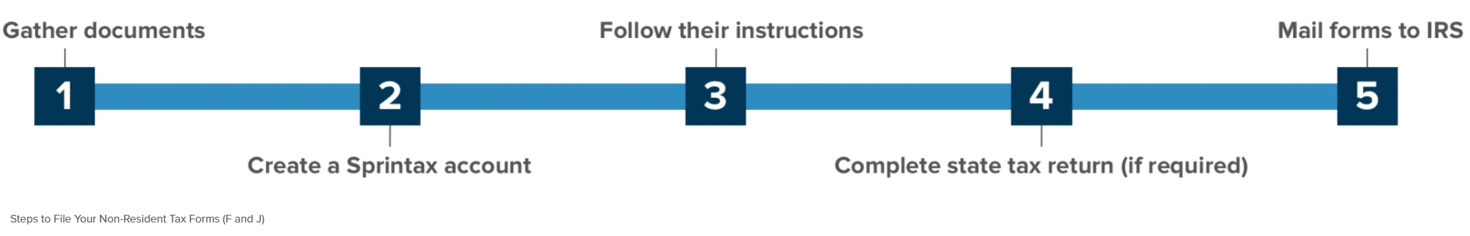

- Gather the documents you may need for Sprintax
 | Document | Description
✔ | Passport
✔ | Visa/Immigration information, including form I-20 (F status) or form DS-2019 (J status)
✔ | Social Security or Individual Taxpayer Identification Number (if you have one) | This is not needed if you had no income and the 8843 is the only form you have to file.
✔* | W-2 | This form reports your wage earnings if you worked. If you had more than one employer you should get a W-2 from each employer. It is issued by the end of January for the previous year. Make sure all employers from last year have an up-to-date address for you. If you are an Au Pair you can use your bank statements to report your US income as generally, Au pairs do not receive W-2’ forms.
✔ | U.S. entry and exit dates for current and past visits to the U.S. | In addition to passport stamps, you can review or print your U.S.travel history here
✔* | 1099 | This form reports miscellaneous income. Can be interest on bank accounts, stocks, bonds, dividends, earning through freelance employment

- Create a Sprintax Account:
You can create a user account by visiting the Sprintax website and creating a UserID and password or if you have an existing account on Sprintax you can log in using your existing credentials.

- Follow the Sprintax instructions
If you had No U.S. Income: Sprintax will generate a completed Form 8843 for you and each of your dependents (if you have any).
With U.S. Income: Sprintax will generate your "tax return documents", including either a 1040NR-EZ or a longer form 1040NR, depending on your circumstances.

- (With U.S. income only) If required, complete your state tax return
After you finish your federal return, Sprintax will inform you if you need to complete a state tax return. If so, they will give you the option to use Sprintax for an individual fee. However, it is your choice to use them or to do the state tax return on your own.
- Mail your completed federal and/or state forms to IRS and/or state tax authorities
Remember to read the mailing instructions that Sprintax provides. If you have dependents, each one must mail their 8843 in a separate envelope.

Need Sprintax Support?
If you need help while using Sprintax, contact them:
24/7 Live Chat Help
Refer to their FAQs
email at hello@sprintax.com

Sprintax Educational Tax Videos and Blog:
You also have access to the Sprintax YouTube account where there are a number of educational videos on non-resident taxes to provide further clarity on the subject of using Sprintax and non-resident tax. There is also a Sprintax Blog which go through tax related topics and can be of use to you.
https://youtu.be/DgcLFMYgpHo

DISCLAIMER: Our institution are NOT permitted to assist nonresidents with any IRS tax form preparation or tax related questions. The information provided is intended for your benefit. Any questions or concerns should be directed to Sprintax, a certified tax preparer or a local IRS field office.

